Calculus 1 Lecture 3.1: Increasing/Decreasing and Concavity of Functions

Increasing intervals of a function will have a positive slope
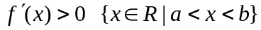

Decreasing intervals of a function will have a negative slope
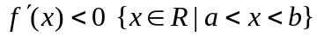

A slope of zero will be a maximum / minimum value of a function or the function will be a horizontal line.
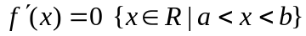

Concavity
The direction of the curvature of the line of the function.
How a curve is increasing and decreasing. Second derivative is the direction of the curve.

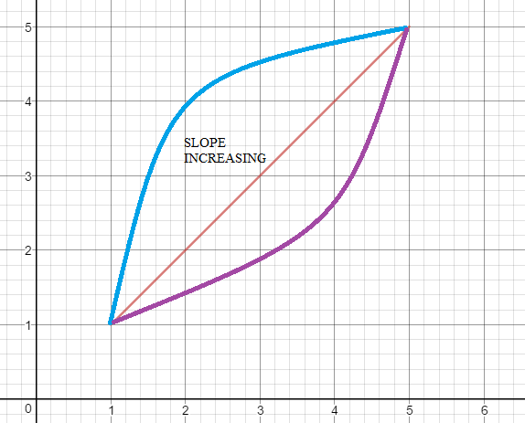

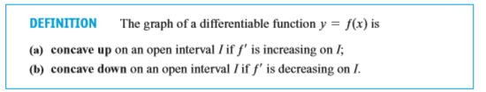
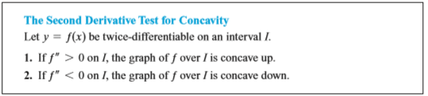

Inflection point is where the graph changes from concave up to concave down or vice versa.
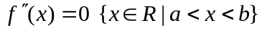 Possible inflection point

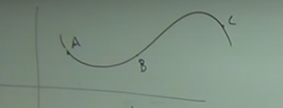

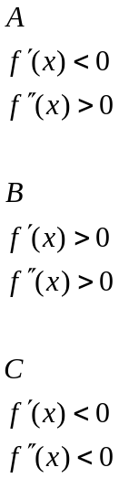

Relative extrema
Relative Maximum
High point of an interval (peak)
Where a function changes from increasing to decreasing slope

Relative Minimum
Low point of an interval. Valley.
Where a function changes from decreasing to increasing slope

Critical points of graph are when the slope = 0
The point at which a curve has a horizontal tangent(slope=0) is called a critical number.

Find all critical numbers of all function set the first derivative to zero and solve equation.
If you have a denominator set it to zero as well. (asymptotes)

Example
Find the critical numbers of 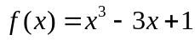
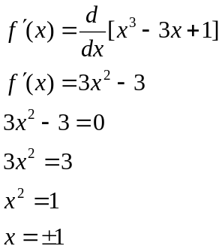

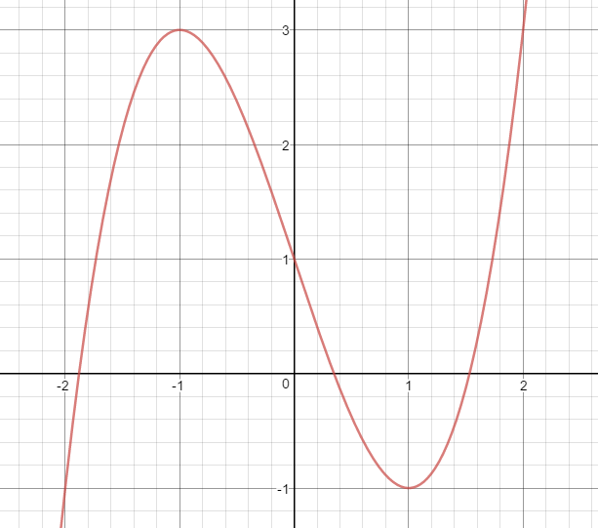

Absolute Maximum
Highest point on an interval

Absolute Minimum
Lowest point on an interval

Some graphs do not have an absolute maximum or minimum 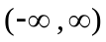
A continuous function may or may not have an absolute maximum and absolute minimum on a open interval (a,b)

But every continuous function has an absolute maximum and absolute minimum on a closed interval
[a,b]

Closed interval
Absolute max/min values will occur at critical numbers or the end points of the interval.

Open interval
An open interval does not include the endpoints.(a,b) in the determination of the absolute maximum and minimum of
the function. The function will only have a potential absolute maximum value and absolute minute value at critical points (slope = 0)

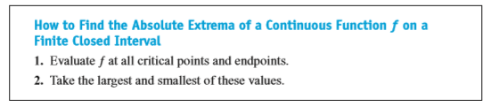
Example
Find the absolute maximum and minimum
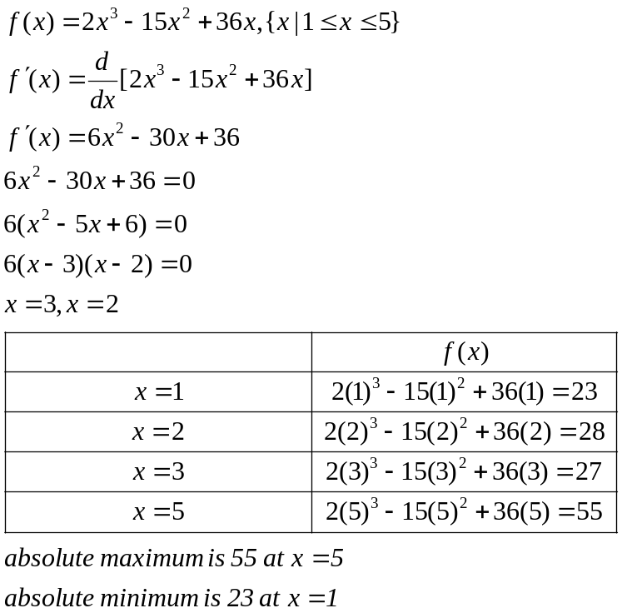

Example
Find the absolute maximum and minimum
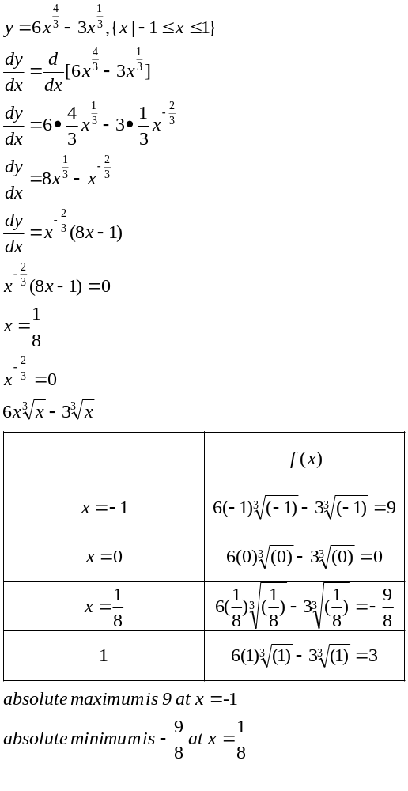

Example
Find the absolute maximum and minimum
